Gel FORM T

Direct Assessment of Writing

Grade 8

Persuasive

Writing Prompt

More and more people use computers, but not everyone agrees that this benefits society. Those who support advances in technology believe that computers have a positive effect on people. They teach hand-eye coordination, give people the ability to learn about faraway places and people, and even allow people to talk online with other people. Others have different ideas. Some experts are concerned that people are spending too much time on their computers and less time exercising, enjoying nature, and interacting with family and friends.

Write a letter to your local newspaper in which you state your opinion on the effects computers have on people. Persuade the readers to agree with you.

When you write, be sure to  state your opinion about the effects of computers.

* give detailed reasons that will persuade readers of the local newspaper to agree with your position.
* organize your ideas well and present them clearly.



General Guidelines:

* The grade seven and eight written responses are first drafts written by students in forty-five minutes in reaction to a prompt designed to elicit persuasive writing. Trained readers score these timed responses holistically, which means that they determine a score based on the overall impression most often gained from a single reading of the response.
* This rubric outlines a six-point scale. Each score point on that scale is described by an overall statement which captures the essence of the response. The elements of the response (elaboration, organization, fluency and audience awareness) that are typical for that score point are described below the overall statement. Individual responses may be stronger in one feature and weaker in another. In other words, the list of features at each score point, while helpful, cannot perfectly describe every response in a score-point category.
* A committee of expert readers uses this rubric as a guide to select anchor papers for each score point. Anchor papers are examples of actual student work. The committee prepares an anchor set composed of several papers at each score point. They deliberately select papers to show an appropriate range of writing skill for each score point and to represent the variety of approaches students take when addressing the writing prompt. Trained readers rely heavily on these anchor sets to guide their scoring.

Errors in spelling, punctuation, grammar, and usage are not considered as part of the criteria for scoring samples. Also, papers receive a score based on the work the student did complete even if they seem to be unfinished. Because the writing sample is a timed response, it is generally assumed that these errors and omissions could have been corrected if the student had been given an opportunity to revise and edit. Readers are therefore trained to read through these errors when they score student papers.

Score Point 1: An undeveloped response that may take a position but offers no more than very  minimal support.

Typical elements:

* Contains few or vague details. 
* Is awkward and fragmented.
* May be difficult to read and understand.  May show no awareness of audience.

Score Point 2: An under-developed response that may or may not take a position. Typical elements:

* Contains only general reasons with unelaborated and/or list-like details.
* Shows little or no evidence of organization.

May be awkward and confused or simplistic.  May show little awareness of audience.

 Score Point 3: A minimally-developed response that may take a position, but with inadequate support and details. Typical elements:

* Has reasons with minimal elaboration and more general than specific details. o Shows some organization.
* May be awkward in parts with few transitions. o Shows some awareness of audience. 

Score Point 4: A somewhat-developed response that takes a position and provides adequate support.

Typical elements:

* Has adequately elaborated reasons with a mix of general and specific details.  Shows satisfactory organization.
* May be somewhat fluent with some transitional language. ' Shows adequate awareness of audience.

Score Point 5: A developed response that takes a clear position and provides reasonably persuasive support. Typical elements:

* Has moderately well elaborated reasons with mostly specific details.

Exhibits generally strong organization.

* May be moderately fluent with transitional language throughout.  May show a consistent awareness of audience.

Score Point 6: A well-developed response that takes a clear and thoughtful position and provides persuasive support. Typical elements:

* Has fully elaborated reasons with specific details.
* Exhibits strong organization.
* Is fluent and uses sophisticated transitional language.  May show a heightened awareness of audience.

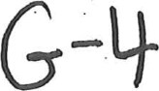



Score Point 1: An undeveloped response that may take a position but offers no more than very minimal support.

Typical elements:

Contains few or vague details. o Is awkward and fragmented.

* May be difficult to read and understand.  May show no awareness of audience.

|  |  |  |  |
| --- | --- | --- | --- |
| |  | | --- | | Score Point: 1  This is an undeveloped response with few details. The writer states that computers benefit society in many ways and provides a few unelaborated reasons (you learn better; you develop a better memory; show you how to get to a proxy). The response is brief with minimal support; more elaboration is needed for a higher score.    Page 5 GO ON | | | 283184b | |  |
|  |

# nun

|  |  |  |  |
| --- | --- | --- | --- |
| |  | | --- | | DIRECTIONS  Begin writing your paper on the lines below. Only what you write on pages 5 through 7 will be scored.              Score Point: 1  The writer of this undeveloped response believes that computers do not have an effect on people (people can get off their computers anytime they want) but are good to have for a few reasons (you can cash your check, talk to people, get a job). The response is brief with very minimal support; more development is needed for a higher score.                Page 5 GO ON | | 2831770 | |  |
|  |

7

Score Point 2: An under-developed response that may or may not take a position.

Typical elements:

* Contains only general reasons with unelaborated and/or list-like details. e Shows little or no evidence of organization.
* May be awkward and confused or simplistic.  May show little awareness of audience.

DIRECTIONS

Begin writing your paper on the lines below. Onty what you write on pages 5 through 7 will be scored.

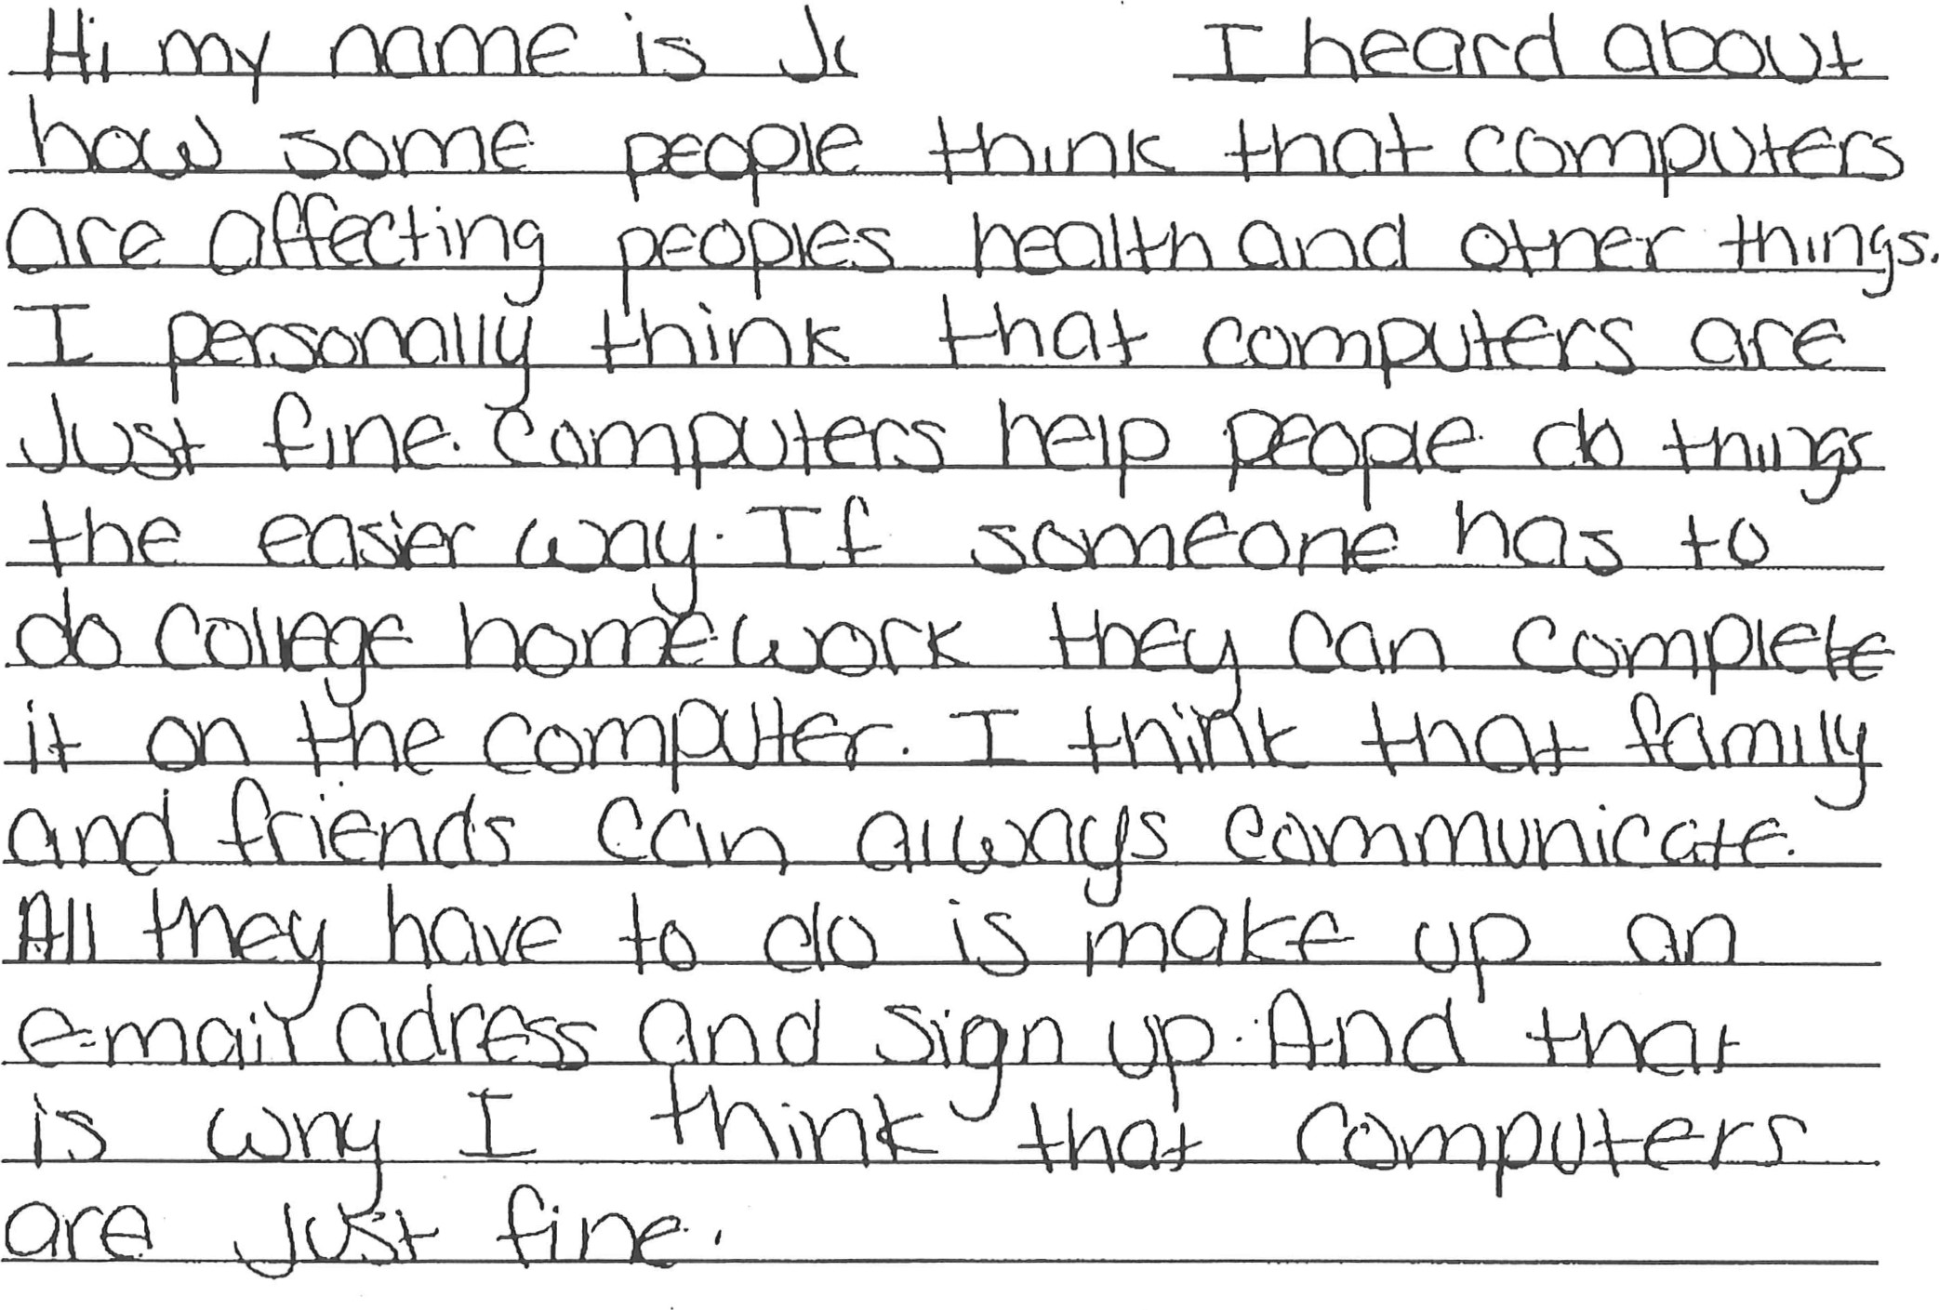

Score Point: 2

This is an under-developed response. The writer states the position that "computers are just fine" and provides three reasons in support (do things the easier way; do college homework; communicate with family and friends). The first two reasons are unelaborated, but the third includes a brief extension (make up an e-mail address and sign up). There is little evidence of organization, but there is enough development for a

Page 5 GO ON 

2831483

|  |
| --- |
| DIRECTIONS  Begin writing your paper on the lines below. Only what you write on pages 5 through 7 will be scored.    Score Point: 2  This writer takes the position that computers are bad for people and provides a few reasons  supported with some specific details (damages your eyes, websites and games). However, there is little evidence of organization, and the response is under developed overall. More elaboration is needed for a higher score. |
|  |

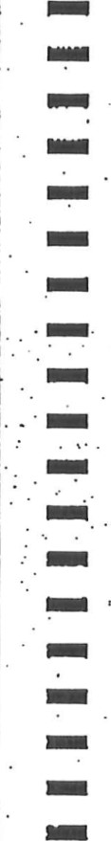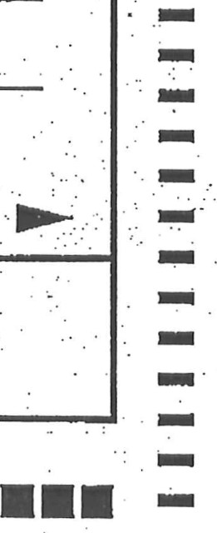

|  |  |  |  |  |  |  |  |  |  |  |  |  |  |  |  |  |  |  |
| --- | --- | --- | --- | --- | --- | --- | --- | --- | --- | --- | --- | --- | --- | --- | --- | --- | --- | --- |
| DIRECTIONS  Begin writing your paper on the lines below. Only what you write on pages 5 through 7 will be scored,               |  |  |  |  |  |  | | --- | --- | --- | --- | --- | --- | |  | | |  | | Q. | |  | e |  | (Oe V- | Cle | | | he-\p | |  |  |  | |     Score Point: 2  This writer thinks that computers have both negative (bad grades in school) and positive effects (help with homework). Much of the elaboration is either general (they don't understand it) or list-like (taxes, homework, projects for work or school), and the response is under developed overall. Some organization is demonstrated through the    use of basic transitions (for example, also), but more elaboration is needed for a higher score.          Page 5 GO ON |
|
| 8 2831946 |

Score Point 3: A minimally-developed response that may take a position, but with inadequate support and details.

Typical elements:

* Has reasons with minimal elaboration and more general than specific details. e Shows some organization.
* May be awkward in parts with few transitions.  Shows some awareness of audience.

## DIRECTIONS

 Begin writing your paper on the lines below. Only what you write on pages 5 through 7 will be scored.



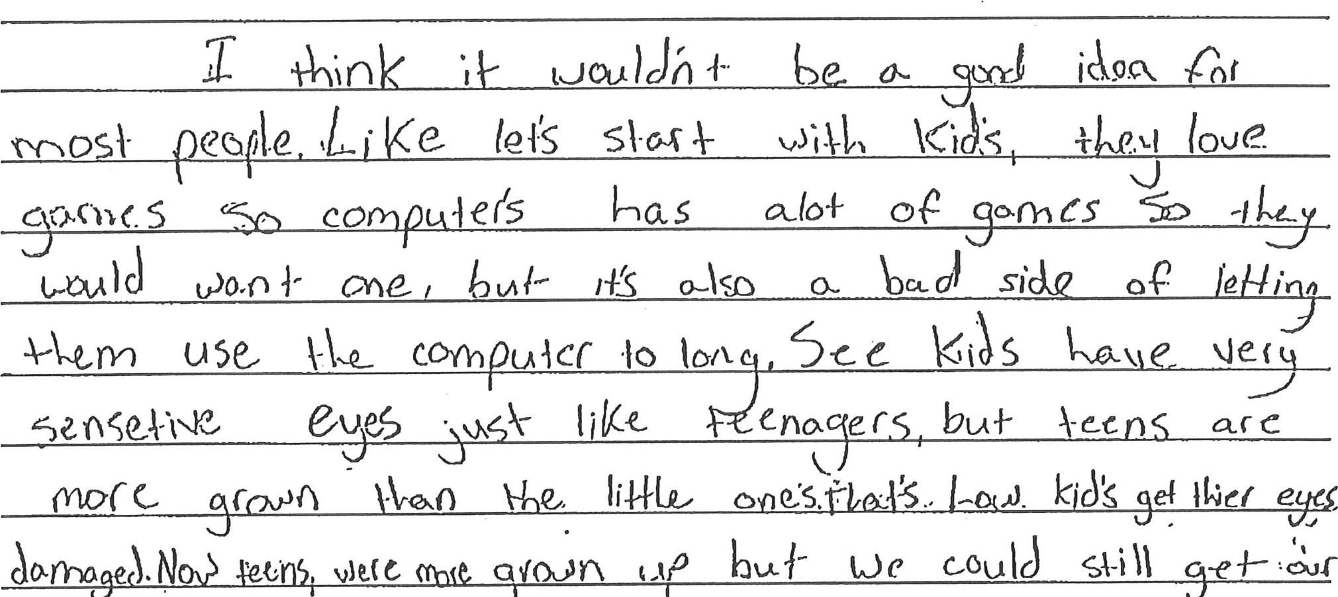cxo.q«. S co oe (M'hCS

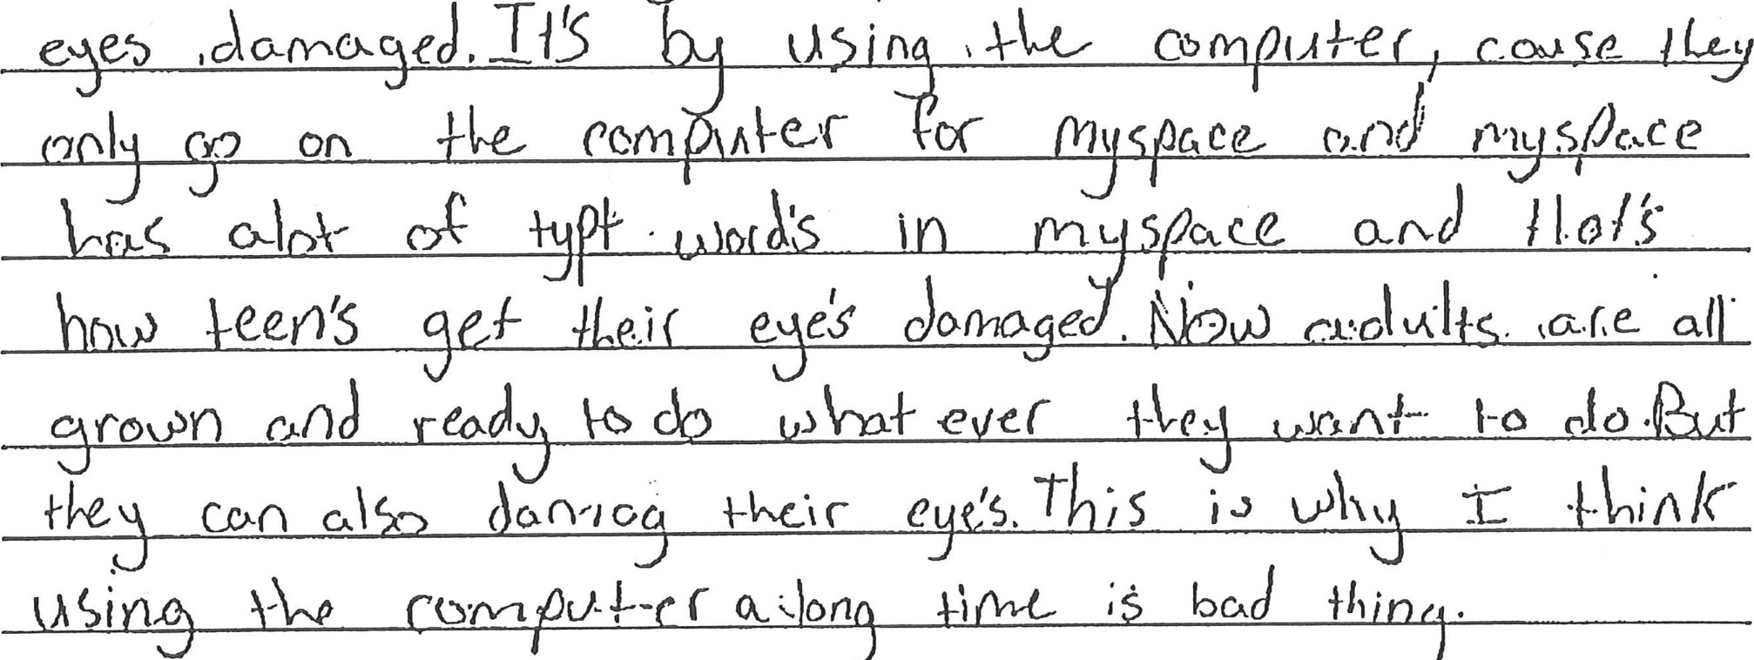eJ .00 SP-

 Score Point: 3

 This is a minimally-developed response with inadequate support and detail. The writer takes the position that computers can be harmful to the eyes and then addresses eye 



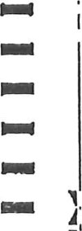damage to three groups of people (kids, teens, adults). A few specific details are included (sensitive eyes, MySpace), but elaboration is minimal. Some organization is demonstrated but few transitions are used. Overall, the response is sufficiently developed to move into the score point "3" range.

2831601 

|  |  |  |  |  |  |
| --- | --- | --- | --- | --- | --- |
| |  | | --- | |  | | DIRECTIONS  Begin writing your paper on the lines below. Only what you write on pages 5 through 7 will be scored.      Page  5 | | 2831079 | | nn | |  |
|  |
|  |
|  |
|  |

|  |  |  |  |  |
| --- | --- | --- | --- | --- |
|  | |  | | --- | | G-/3)9 | | Score Point: 3  The writer of this minimally-developed response thinks that computers have a positive effect on people and presents three reasons in support (talking to other people on the internet; learning about far away places; helping with school). Some specific details are provided (MySpace; Egypt or Brazil), but the elaboration is inadequate and often general (help you get information for things). The response shows some organization, but more specific development is needed for a higher score.              Page 6 | | PLEASE DO NOT WRITE IN THIS AREA  1 1b 2831079 gnoouuonoouoounononoo 2831079 | |
|  |
|  |
|  |
|  |

|  |  |  |  |  |  |  |  |  |  |  |  |  |  |  |  |  |  |  |  |  |  |  |  |  |  |  |  |  |  |  |
| --- | --- | --- | --- | --- | --- | --- | --- | --- | --- | --- | --- | --- | --- | --- | --- | --- | --- | --- | --- | --- | --- | --- | --- | --- | --- | --- | --- | --- | --- | --- |
| DIRECTIONS  Begin writing your paper on the lines below. Only what you write on pages 5 through 7 will be scored.           |  |  |  |  |  |  | | --- | --- | --- | --- | --- | --- | |  | I ue.Ql | | 10 Ike |  |  | |  |  | |  |  |  | |  |  |  |  |  |  | |  |  | | Q Fez Ld |  | ate | |  |  | | coon.( |  | k |   \-hcv  don  h  Score  Point:  3  This writer takes the position that the effects of computers are different for everyone all depends on how you spend your time) and offers suggestions to parents to get their |
| child off the computer (give them a time limit; get security; get them into sports). The response is minimally developed with inadequate support. Stronger organization and more development are needed for a higher score. |

(it

0331699 

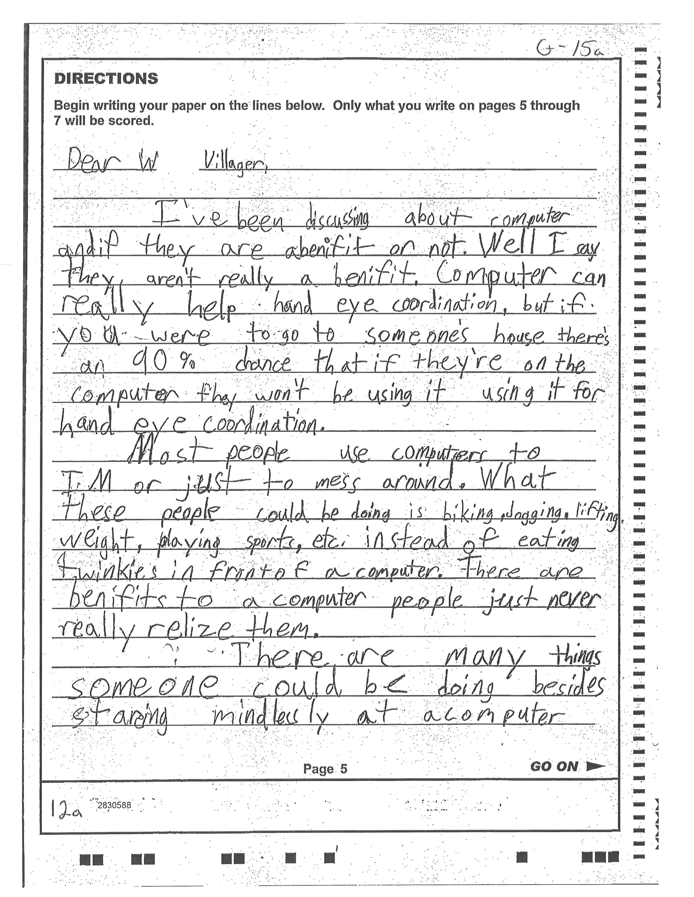

G -15b

|  |  |  |  |
| --- | --- | --- | --- |
|  | |  | | --- | | Score Point: 3  This writer thinks that computers do not benefit people and offers several examples to support this position. While there are some specific ideas (eating Twinkies in front of the computer, staring mindlessly at a computer), elaboration is mostly general (people are wasting their life) and sometimes repetitive (jogging and biking). The response demonstrates some organization, but the elaboration is minimal overall. More specific development is needed for a higher score.              Page 6 | | PLEASE DO NOT WRITE IN THIS AREA  2830588 conunaoooonoouononoo 2830588 | |
|  |
|  |
|  |
|  |

Score Point 4: A somewhat-developed response that takes a position and provides adequate support.

Typical elements:

Has adequately elaborated reasons with a mix of general and specific details. o Shows satisfactory organization.

* May be somewhat fluent with some transitional language.  Shows adequate awareness of audience.

G-17&

|  |
| --- |
| DIRECTIONS  Begin writing your paper on the lines below. Only what you write on pages 5 through 7 will be scored.          Page 5 GO ON |
| 2830105 |

6-1710

|  |  |  |  |
| --- | --- | --- | --- |
|  | |  | | --- | | Score  Point:  4  This is a somewhat-developed response in which the writer addresses three positive benefits of computers (better hand-eye coordination; learning about faraway places; chatting with friends and family). Elaboration is an adequate mix of general and specific details (clicking and mouse moving; The Andes of Chile; talk to her with a webcam). Organization is satisfactory, and there is enough development for a "4."  Page 6 | | PLEASE DO NOT WRITE IN THIS AREA  3b 2830105  2830105 | |
|  |
|  |
|  |
|  |
|  |
|  |
|  |
|  |

|  |  |
| --- | --- |
| DIRECTIONS  Begin writing your paper on the lines below. Only what you write on pages 5 through  __D_ecx_____  7  will  be  scored.  Page 5 GO ON | |
| 2830352 | |
|  | |  | | --- | | Ihe-          Score Point: 4  In this somewhat-developed response, the writer takes the position that children spend too much time on the computer and presents some negative effects while also providing advice to parents on how to help. Elaboration is an adequate mix of general (do something else) and specific details (when it's 850 outside). Organization is satisfactory, though there is minor repetition in the third paragraph, and the response is somewhat fluent. More in-depth and specific development is needed for a higher score.    Page 6 | | PLEASE DO NOT WRITE IN THIS AREA t-- 2830352  2830352 | | |
|  |
|  |
|  |
|  |
|  |
|  |
|  |
|  |
|  |

— unn

|  |  |  |  |  |  |  |  |  |  |  |  |  |  |  |  |  |  |  |  |  |  |  |  |  |  |  |  |  |  |  |  |  |  |  |  |  |  |  |  |  |  |  |  |  |  |  |  |  |  |  |  |  |  |  |  |  |  |  |  |  |  |  |  |  |  |  |  |  |  |  |  |  |  |  |  |  |  |  |  |  |  |  |  |  |  |  |  |  |  |  |  |  |  |  |  |  |  |  |  |  |  |  |  |  |  |  |  |  |  |  |
| --- | --- | --- | --- | --- | --- | --- | --- | --- | --- | --- | --- | --- | --- | --- | --- | --- | --- | --- | --- | --- | --- | --- | --- | --- | --- | --- | --- | --- | --- | --- | --- | --- | --- | --- | --- | --- | --- | --- | --- | --- | --- | --- | --- | --- | --- | --- | --- | --- | --- | --- | --- | --- | --- | --- | --- | --- | --- | --- | --- | --- | --- | --- | --- | --- | --- | --- | --- | --- | --- | --- | --- | --- | --- | --- | --- | --- | --- | --- | --- | --- | --- | --- | --- | --- | --- | --- | --- | --- | --- | --- | --- | --- | --- | --- | --- | --- | --- | --- | --- | --- | --- | --- | --- | --- | --- | --- | --- | --- | --- | --- |
| |  |  |  |  |  |  |  |  |  |  |  |  |  |  |  |  |  |  |  |  |  |  |  |  |  |  |  |  |  |  |  |  |  |  |  |  |  |  |  |  |  |  |  |  |  |  |  |  |  |  |  |  |  |  |  |  |  |  |  |  |  |  |  |  |  |  |  |  |  |  |  |  |  |  |  |  |  |  |  |  |  |  |  |  |  |  |  |  |  |  |  |  |  |  |  |  |  |  |  |  |  |  |  |  |  |  |  |  | | --- | --- | --- | --- | --- | --- | --- | --- | --- | --- | --- | --- | --- | --- | --- | --- | --- | --- | --- | --- | --- | --- | --- | --- | --- | --- | --- | --- | --- | --- | --- | --- | --- | --- | --- | --- | --- | --- | --- | --- | --- | --- | --- | --- | --- | --- | --- | --- | --- | --- | --- | --- | --- | --- | --- | --- | --- | --- | --- | --- | --- | --- | --- | --- | --- | --- | --- | --- | --- | --- | --- | --- | --- | --- | --- | --- | --- | --- | --- | --- | --- | --- | --- | --- | --- | --- | --- | --- | --- | --- | --- | --- | --- | --- | --- | --- | --- | --- | --- | --- | --- | --- | --- | --- | --- | --- | --- | --- | | DIRECTIONS  Begin writing your paper on the lines below. Only what you write on pages 5 through 7 will be scored.   |  |  |  |  |  |  |  |  |  |  | | --- | --- | --- | --- | --- | --- | --- | --- | --- | --- | |  | | |  | CD | | |  |  | | |  | | | | | | (onf)v er | ve no u. e | so z | | | /?47L | | | | | | | c ever |  | | |  | | | | |  | |  |  |  | |  |  | | |  | | | +0 | 40 ol{er | | | oo | |  | | | | |  |  | |        |  |  |  |  |  |  |  |  |  |  | | --- | --- | --- | --- | --- | --- | --- | --- | --- | --- | |  | | 0 | | | | | 4-/)er- | n •01-/0%0. | | | h a sc boo | | | | | | | o | 0 0 4-0 | | |  | or SK. | | | | o | W | | | |  |  | | | |  |  | | | |  | | |  |  | |  | | |   Page 5 GO ON | | 2830357 | |  |

|  |  |  |  |  |  |  |  |  |  |  |  |  |  |  |  |  |  |  |  |  |  |  |  |  |  |  |  |  |  |  |  |  |  |  |  |  |  |  |  |  |  |  |  |  |  |  |  |  |  |  |  |  |  |  |  |  |  |  |  |  |  |  |  |  |  |  |  |  |  |  |  |  |  |  |  |  |  |  |  |  |  |  |  |  |  |  |  |  |  |  |  |  |  |  |  |  |  |  |  |  |  |  |  |  |
| --- | --- | --- | --- | --- | --- | --- | --- | --- | --- | --- | --- | --- | --- | --- | --- | --- | --- | --- | --- | --- | --- | --- | --- | --- | --- | --- | --- | --- | --- | --- | --- | --- | --- | --- | --- | --- | --- | --- | --- | --- | --- | --- | --- | --- | --- | --- | --- | --- | --- | --- | --- | --- | --- | --- | --- | --- | --- | --- | --- | --- | --- | --- | --- | --- | --- | --- | --- | --- | --- | --- | --- | --- | --- | --- | --- | --- | --- | --- | --- | --- | --- | --- | --- | --- | --- | --- | --- | --- | --- | --- | --- | --- | --- | --- | --- | --- | --- | --- | --- | --- | --- | --- | --- | --- |
| |  |  |  |  |  |  |  |  | | --- | --- | --- | --- | --- | --- | --- | --- | | Scud | | | |  | g 10people. use | I nvernc/  ( |  | |  | | | |  | a (q Over |  |  | |  | | | |  |  |  |  | |  | | |  |  | 00 C n VS 710 |  | (J | | na C | | | |  | 61S O') | ma'.s P |  | |  |  |  | |  | 10, |  | ard |   zl- V" th)ernc+a   |  |  |  |  |  |  |  |  | | --- | --- | --- | --- | --- | --- | --- | --- | |  |  | |  |  | -o r |  | i')pSSo P | |  | | | 0 06 OF | | / T/ |  | 0- | | O. Po - | | | o/ e or | | {hos |  |  | |  | | |  | |  |  |  | |  | | c onr | ; n, r/- | |  |  |  | |  | | |  | |  |  |  | |  | | | 10 0; | | eo,o/e, | / |  |   C dreams, s/req»n is P con a anol wa/c/ videos al san ' /me. -l/ js 67. Peo I    Score Point: 4  This writer takes the position that computers have a positive effect on society and presents three ways that computers can be helpful (if you're bored, to gather information, to talk to other people). Elaboration is an adequate mix of general (that's a lot of people) and specific details (go to Google; make YouTube accounts and create streams). Even though there is some repetition, the organization is satisfactory with some use of transitions. Stronger organization and more in-depth development are needed for a higher score. |
| PLEASE DO NOT WRITE IN THIS AREA  2830357  2830357 |

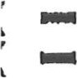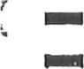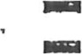. :



|  |  |  |  |
| --- | --- | --- | --- |
| |  | | --- | | DIRECTIONS  Begin writing your paper on the lines below. Only what you write on pages 5 through 7 will be scored. | | 2830å59 | |  |
|  |





|  |  |  |  |  |  |  |  |  |  |  |  |  |  |  |  |  |  |  |  |  |  |  |  |  |  |  |  |  |  |  |  |  |  |  |  |  |
| --- | --- | --- | --- | --- | --- | --- | --- | --- | --- | --- | --- | --- | --- | --- | --- | --- | --- | --- | --- | --- | --- | --- | --- | --- | --- | --- | --- | --- | --- | --- | --- | --- | --- | --- | --- | --- |
|  | |  |  |  |  |  |  |  |  |  |  |  |  |  |  |  |  |  |  |  |  |  |  |  |  |  |  |  |  |  |  |  |  |  |  |  | | --- | --- | --- | --- | --- | --- | --- | --- | --- | --- | --- | --- | --- | --- | --- | --- | --- | --- | --- | --- | --- | --- | --- | --- | --- | --- | --- | --- | --- | --- | --- | --- | --- | --- | --- | | |  |  |  |  |  |  |  |  |  |  |  |  |  |  |  |  |  |  |  |  |  |  |  |  |  |  |  |  |  |  |  |  |  |  | | --- | --- | --- | --- | --- | --- | --- | --- | --- | --- | --- | --- | --- | --- | --- | --- | --- | --- | --- | --- | --- | --- | --- | --- | --- | --- | --- | --- | --- | --- | --- | --- | --- | --- | | |  |  |  |  |  |  |  |  | | --- | --- | --- | --- | --- | --- | --- | --- | |  |  | |  | | | e Ceu5Z | | |  |  | | ace | | | |  | |  | cur es | |  | | kupeJ | | | |  | |  | |  | | | | |  |     Score Point: 4  The writer of this somewhat-developed response chooses to examine both the positive and negative effects of technology as a whole before concluding that technology is a benefit to society. Elaboration is an adequate mix of general (learn things about places) and specific details (an electric socket overloaded or a computer overheated). Satisfactory organization is demonstrated through the use of transitional language, and the response is somewhat fluent. Many examples are provided, but more in-depth and specific development is needed for a higher score.  PLEASE DO NOT WRITE IN THIS AREA  b 2830859 nouooooouoonnoououonoo 2830859 | |
|  |
|  |
|  |
|  |
|  |
|  |

Score Point 5: A developed response that takes a clear position and provides reasonably persuasive support.

Typical elements:

* Has moderately well elaborated reasons with mostly specific details. 

' Exhibits generally strong organization.

' May be moderately fluent with transitional language throughout. o May show a consistent awareness of audience.



|  |  |  |  |  |  |  |  |  |  |  |  |  |  |  |  |  |  |  |  |  |  |  |  |  |  |  |  |  |  |  |  |
| --- | --- | --- | --- | --- | --- | --- | --- | --- | --- | --- | --- | --- | --- | --- | --- | --- | --- | --- | --- | --- | --- | --- | --- | --- | --- | --- | --- | --- | --- | --- | --- |
| |  |  |  |  |  |  |  |  |  |  |  |  |  |  |  |  |  |  |  |  |  |  |  |  |  |  |  |  |  | | --- | --- | --- | --- | --- | --- | --- | --- | --- | --- | --- | --- | --- | --- | --- | --- | --- | --- | --- | --- | --- | --- | --- | --- | --- | --- | --- | --- | --- | | DIRECTIONS  7 will be scored.  fid\Jcxnc26 in   |  |  |  |  |  |  | | --- | --- | --- | --- | --- | --- | | |  |  | | --- | --- | | hejr | or excercisin | |  |  | |  | |  |      |  |  |  |  |  |  |  | | --- | --- | --- | --- | --- | --- | --- | |  | |  | |  | Vo have | | |  |  | | ome | crimi (A | 0m | | |  |  | | |  |  |  | | | •2836565 | |  |
|  |
|  |
|  |
|  |

|  |  |  |  |  |  |  |  |  |  |  |  |  |  |  |  |  |  |  |
| --- | --- | --- | --- | --- | --- | --- | --- | --- | --- | --- | --- | --- | --- | --- | --- | --- | --- | --- |
| Com {he rm  CDnrR kec  COOASQ-S  A ruin h ce  f.o.r AAA med/cönes.  Toe S q  CO(hPUikCr worse.  Be excerccse he a f åÄIÄ   |  |  |  |  |  |  |  |  |  | | --- | --- | --- | --- | --- | --- | --- | --- | --- | |  | VY\CS | vJ CQk | ode | live | | {-0 q | | e | |  |  |  |  |  |  |  |  |  |   Page 6 |
| PLEASE DO NOT WRITE IN THIS AREA  goaoonneooonuoonoaonoo 2830565 |

|  |
| --- |
| make If ves DF    Score Point: 5  This developed response contains three moderately well elaborated reasons that explain why computers do not benefit society (not spending enough time with family;  causing harm to nature; not exercising enough). Each reason is elaborated with mostly specific details (family time increases grade level by 15% and reduces crime rates by 38%). The response exhibits generally strong organization with transitional language throughout  and is moderately fluent. There is enough specific development for a score of "5". |
| 2830565 |
|  |

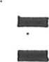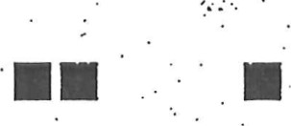

|  |
| --- |
| DIRECTIONS  Begin writing your paper on the lines below. Only what you write on pages 5 through 7 will be scored.    Page 5 |
|
| 2831638 |





|  |  |  |  |  |  |  |  |  |  |  |  |  |  |  |  |
| --- | --- | --- | --- | --- | --- | --- | --- | --- | --- | --- | --- | --- | --- | --- | --- |
| 久  。  ィ  (  ,  。  ひ  記  化  乙  ¥  ←  。  5  ;  門  く  長  」  へ  ヤ  立  歙  、  ~  亡  朝 5 レ、 0 d 90 ち第, く 十0 ラぞ4  ラみ-てが・エへ cレ 气。。な 。ヤ 化 0, し い5 ↓,」 村 q90 しいトげk c,eJ人(厄,イ, 5 しる5。( Ⅵ導( oe.叭ィに一 0- 髭 w砿 。尾, ー f)。 ′ 气   |  | | --- | | の川や、レ「51辺しp ;十0、。高ーソby |   レト。0。い の5つ一亠・・レ0 m叱ト    イへっ   |  |  |  |  |  |  |  | | --- | --- | --- | --- | --- | --- | --- | | 00 民く <-め こ ( | | % 1 ・ | す騒レ | ム( | こ | . Cts | |  | 巳〇員斗乙へ( | ⅳ 0 |  |  |  | o紜。4例 |   ろ~ て に0 9 十“ , 戸 準 ーk - ー0 。、ト 。  7の 9 (レ-ー久。ィーラ。↓レーへ「ぞ-ー~て引  Page 6 |
| PLEASE DO NOT•WRITEIN THIS AREA  2831538 ロ〇〇■臨0 ■〇〇■〇■ ■〇〇■ ■〇住00〇〇2831538 |

了

0

|  |
| --- |
| Score  Point:  5  The writer of this developed response takes the position that computers have a positive effect  on society. Each of the three reasons are moderately well elaborated using mostly specific details that include personal examples (just last week I was in need of help on homework), statistics (10 out of 20 people have gotten their college diploma over the internet), and quotations. Effective transitional language (in fact; but I'm not the only one) contributes to the overall fluency of the response, and organization is generally strong. More in-depth elaboration is needed for a "6."    Page 7 |
|
|
|
|
|
|
| 2831538 |



|  |  |  |  |  |  |  |  |  |  |  |  |  |  |  |  |  |  |  |  |  |  |  |  |  |  |  |  |  |  |  |  |  |  |  |  |  |  |  |  |  |  |  |  |  |  |  |  |  |  |  |  |  |  |  |  |  |  |  |  |  |  |  |  |  |  |  |  |  |  |  |  |  |  |  |  |  |  |  |  |  |  |  |  |  |  |  |  |  |  |  |  |  |  |  |  |  |  |  |  |  |  |  |  |  |  |  |  |  |  |  |  |  |  |  |  |  |  |  |  |  |  |  |  |  |  |  |  |  |  |  |  |  |  |  |  |  |  |  |  |  |  |  |  |  |  |  |  |  |  |  |  |  |  |  |  |  |  |  |  |  |  |  |  |  |  |  |  |  |  |  |  |  |  |  |  |  |  |  |  |  |  |  |  |  |  |  |  |  |  |  |  |  |  |  |  |  |  |  |  |  |  |  |  |  |  |  |  |  |  |  |  |  |  |  |  |  |  |  |  |  |  |  |  |  |  |  |
| --- | --- | --- | --- | --- | --- | --- | --- | --- | --- | --- | --- | --- | --- | --- | --- | --- | --- | --- | --- | --- | --- | --- | --- | --- | --- | --- | --- | --- | --- | --- | --- | --- | --- | --- | --- | --- | --- | --- | --- | --- | --- | --- | --- | --- | --- | --- | --- | --- | --- | --- | --- | --- | --- | --- | --- | --- | --- | --- | --- | --- | --- | --- | --- | --- | --- | --- | --- | --- | --- | --- | --- | --- | --- | --- | --- | --- | --- | --- | --- | --- | --- | --- | --- | --- | --- | --- | --- | --- | --- | --- | --- | --- | --- | --- | --- | --- | --- | --- | --- | --- | --- | --- | --- | --- | --- | --- | --- | --- | --- | --- | --- | --- | --- | --- | --- | --- | --- | --- | --- | --- | --- | --- | --- | --- | --- | --- | --- | --- | --- | --- | --- | --- | --- | --- | --- | --- | --- | --- | --- | --- | --- | --- | --- | --- | --- | --- | --- | --- | --- | --- | --- | --- | --- | --- | --- | --- | --- | --- | --- | --- | --- | --- | --- | --- | --- | --- | --- | --- | --- | --- | --- | --- | --- | --- | --- | --- | --- | --- | --- | --- | --- | --- | --- | --- | --- | --- | --- | --- | --- | --- | --- | --- | --- | --- | --- | --- | --- | --- | --- | --- | --- | --- | --- | --- | --- | --- | --- | --- | --- | --- | --- | --- | --- | --- | --- | --- | --- | --- | --- | --- | --- | --- | --- | --- | --- | --- |
| |  |  |  |  |  |  |  |  |  |  |  |  |  |  |  |  |  |  |  |  |  |  |  |  |  |  |  |  |  |  |  |  |  |  |  |  |  |  |  |  |  |  |  |  |  |  |  |  |  |  |  |  |  |  |  |  |  |  |  |  |  |  |  |  |  |  |  |  |  |  |  |  |  |  |  |  |  |  |  |  |  |  |  |  |  |  |  |  |  |  |  |  |  |  |  |  |  |  |  |  |  |  |  |  |  |  |  |  |  |  |  |  |  |  |  |  |  |  |  |  |  |  |  |  |  |  |  |  |  |  |  |  |  |  |  |  |  |  |  |  |  |  |  |  |  |  |  |  |  |  |  |  |  |  |  |  |  |  |  |  |  |  |  |  |  |  |  |  |  |  |  |  |  |  |  |  |  |  |  |  |  |  |  |  |  |  |  |  |  |  |  |  |  |  |  |  |  |  |  |  |  |  |  |  |  |  |  |  |  |  |  |  |  |  |  |  |  |  |  |  |  |  |  |  | | --- | --- | --- | --- | --- | --- | --- | --- | --- | --- | --- | --- | --- | --- | --- | --- | --- | --- | --- | --- | --- | --- | --- | --- | --- | --- | --- | --- | --- | --- | --- | --- | --- | --- | --- | --- | --- | --- | --- | --- | --- | --- | --- | --- | --- | --- | --- | --- | --- | --- | --- | --- | --- | --- | --- | --- | --- | --- | --- | --- | --- | --- | --- | --- | --- | --- | --- | --- | --- | --- | --- | --- | --- | --- | --- | --- | --- | --- | --- | --- | --- | --- | --- | --- | --- | --- | --- | --- | --- | --- | --- | --- | --- | --- | --- | --- | --- | --- | --- | --- | --- | --- | --- | --- | --- | --- | --- | --- | --- | --- | --- | --- | --- | --- | --- | --- | --- | --- | --- | --- | --- | --- | --- | --- | --- | --- | --- | --- | --- | --- | --- | --- | --- | --- | --- | --- | --- | --- | --- | --- | --- | --- | --- | --- | --- | --- | --- | --- | --- | --- | --- | --- | --- | --- | --- | --- | --- | --- | --- | --- | --- | --- | --- | --- | --- | --- | --- | --- | --- | --- | --- | --- | --- | --- | --- | --- | --- | --- | --- | --- | --- | --- | --- | --- | --- | --- | --- | --- | --- | --- | --- | --- | --- | --- | --- | --- | --- | --- | --- | --- | --- | --- | --- | --- | --- | --- | --- | --- | --- | --- | --- | --- | --- | --- | --- | --- | --- | --- | --- | --- | --- | --- | --- | --- | | DIRECTIONS  Begin writing your paper on the lines below. Only what you write on pages 5 through 7 will be scored.   |  |  |  |  | | --- | --- | --- | --- | |  | wondced how | u | +ime ou |  |  |  |  |  |  |  |  |  |  |  | | --- | --- | --- | --- | --- | --- | --- | --- | --- | --- | |  |  |  | e co | er eckC |  | ? Have con ufCrs | | | | | ev | | | |  |  | |  | |  | |  | | | | |  | | |  | |  |  |  |  |  |  | | --- | --- | --- | --- | --- | | Corn e s dO(R+ |  | 5 Ack\/ |  |  |   S •n l i e P 0 +1 eo le wou d ree     |  |  |  |  |  |  |  |  |  |  |  |  |  |  |  |  |  |  |  |  |  |  |  | | --- | --- | --- | --- | --- | --- | --- | --- | --- | --- | --- | --- | --- | --- | --- | --- | --- | --- | --- | --- | --- | --- | --- | | A | | | | | | | | | | | | | | | never | | | | | | | | | e(ÄOÖ | | | | | e | | | | | exerci e d | | | | | |  | |  | | OU+ | | | | (cab | | | | | | | | | |  | u *ion (k e | | | | | | | | |  | | | | Owe i k | | | | | |  |  | | | hkb( | | | as e % | | | | | | |  | | | | esol+ | | cause | | | | | | |  | c | | | QAvoces | | | | | |  |  | | | |  | |  | | so | | | | | os com | | | | | | cm | | | OU d | | | | ov | | rex | | c | | A | | | | | | | | | ole | | e | | |  | | | |  | |  | |  | |  |  | | | | | | | | | |  | | |  | | | | |   Page 5 GO ON | | 2830123 | |  |
|  |
|  |
|  |
|  |
|  |

|  |  |  |  |  |  |  |  |  |  |  |  |  |  |  |  |  |  |  |  |  |  |  |  |  |  |  |  |  |  |  |  |  |  |  |  |  |  |  |  |  |  |  |  |  |  |  |  |  |  |  |  |  |  |  |  |  |  |  |  |  |  |  |  |  |  |  |  |  |  |  |  |  |  |  |  |  |  |  |  |  |  |  |  |  |  |  |  |  |  |  |  |  |  |  |  |  |  |  |  |  |  |  |  |  |  |  |  |  |  |  |  |  |  |  |  |  |  |  |  |  |  |  |  |  |  |  |  |  |  |  |
| --- | --- | --- | --- | --- | --- | --- | --- | --- | --- | --- | --- | --- | --- | --- | --- | --- | --- | --- | --- | --- | --- | --- | --- | --- | --- | --- | --- | --- | --- | --- | --- | --- | --- | --- | --- | --- | --- | --- | --- | --- | --- | --- | --- | --- | --- | --- | --- | --- | --- | --- | --- | --- | --- | --- | --- | --- | --- | --- | --- | --- | --- | --- | --- | --- | --- | --- | --- | --- | --- | --- | --- | --- | --- | --- | --- | --- | --- | --- | --- | --- | --- | --- | --- | --- | --- | --- | --- | --- | --- | --- | --- | --- | --- | --- | --- | --- | --- | --- | --- | --- | --- | --- | --- | --- | --- | --- | --- | --- | --- | --- | --- | --- | --- | --- | --- | --- | --- | --- | --- | --- | --- | --- | --- | --- | --- | --- | --- | --- | --- | --- |
|  | |  |  | | --- | --- | | Gつ9 |  | | |  |  |  |  |  |  |  |  | | --- | --- | --- | --- | --- | --- | --- | --- | | o鷲e 5う0 0(丿いex 0障【〇 | | | | |  |  | | |  | 十〇人Ce 0 | | | |  | | | | ( COU | | be (は一伏e | | | WC | | | | 0 Ce 十i(\ | | oけecs ( e | | |  | | | |  | e 6、d朝。ハ0 | | | |  | | ( | | o仼0u5十 | | |  |  |  | | |      |  |  |  |  |  |  |  |  |  |  |  |  |  |  |  | | --- | --- | --- | --- | --- | --- | --- | --- | --- | --- | --- | --- | --- | --- | --- | |  | C | | |  | |  | | | | | | | 十ぐover | | |  | | | | i | | e | ()e co i | | | | | |  | | |  | | | | |  | | |  |  |  |  | •SC U 0印朝 | | | |  | |  | e | | om l) e 5巳 | | | |  | | | WC\ | | 0 0 | |  | | | | |  | | | |  | | | | |  |   OUj5iåe  e  Page  6 | | | PLEASE DO NOT WRITE THIS AREA  2830123 圍■〇■〇住()〇住000〇■〇0 ■ ■ 0 ■〇住0〇2830123 | | |
|  |
|  |
|  |
|  |
|  |
|  |

|  |  |  |  |  |  |  |  |  |  |  |  |  |  |  |  |  |  |  |  |  |  |  |  |  |  |  |  |  |  |  |  |  |  |  |  |  |  |  |  |  |  |  |  |  |  |  |  |  |  |  |  |  |  |  |  |  |  |  |  |  |  |  |  |  |  |  |  |  |  |  |  |  |  |  |  |  |  |  |  |  |  |  |  |  |  |  |  |  |  |  |  |  |  |  |  |  |  |  |  |
| --- | --- | --- | --- | --- | --- | --- | --- | --- | --- | --- | --- | --- | --- | --- | --- | --- | --- | --- | --- | --- | --- | --- | --- | --- | --- | --- | --- | --- | --- | --- | --- | --- | --- | --- | --- | --- | --- | --- | --- | --- | --- | --- | --- | --- | --- | --- | --- | --- | --- | --- | --- | --- | --- | --- | --- | --- | --- | --- | --- | --- | --- | --- | --- | --- | --- | --- | --- | --- | --- | --- | --- | --- | --- | --- | --- | --- | --- | --- | --- | --- | --- | --- | --- | --- | --- | --- | --- | --- | --- | --- | --- | --- | --- | --- | --- | --- | --- | --- | --- |
| |  |  |  |  |  |  |  |  |  |  |  |  |  |  |  | | --- | --- | --- | --- | --- | --- | --- | --- | --- | --- | --- | --- | --- | --- | --- | |  |  | |  | |  | |  |  |  | | |  | | | |  | | | | | | | |  | |  |  | | | | |  | | | |  |  | | | ver | | | | | |  | |  | |  | | |  |  | |  | | | | |  | | |  | | | | |  | | | | | | | | | |   htq   |  |  |  |  |  |  |  |  | | --- | --- | --- | --- | --- | --- | --- | --- | | wkole | | | | |  | |  | |  | |  | | | | o le | | |  |  | |  | "(ô See Side | | | |   iA+Ke  STOP  Page  7 |
| 2830123 |

-

### C -p i/Å

Score Point: 5

In this developed response, the writer takes the position that computers have had a

negative effect on society and addresses three ways that computer time is cutting into more important things (exercising; traveling and exploring; family and friends). These reasons are moderately well elaborated with mostly specific details (53% of America's population is overweight) and effective rhetorical questions. The response is fluent and exhibits strong organization. More development is needed for a "6."

Score Point 6: A well-developed response that takes a clear and thoughtful position and provides persuasive support.

Typical elements:

o Has fully elaborated reasons with specific details.  Exhibits strong organization.

o Is fluent and uses sophisticated transitional language. May show a heightened awareness of audience.

|  |
| --- |
| DIRECTIONS  Begin writing your paper on the lines below. Only what you write on pages 5 through |
|
|  |

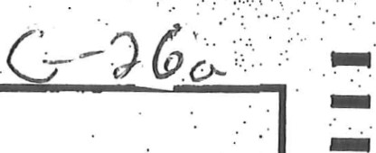



|  |  |  |  |
| --- | --- | --- | --- |
|  | |  | | --- | | ree  (4.00  Page 6 | | PLEASE DO NOT WRITE IN THIS AREA  2830637 goa•oZ00Ä000BÄ00ÆAOÄOA00 2830637 | |

|  |
| --- |
| This writer states that "computers are the future, and we need to embrace it" and presents three reasons in support (improvement to hand-eye coordination; instant and endless information; ways to stay in touch with friends). Each reason is fully elaborated with specific details (search engine or database; how to fold a napkin to look like a bunny) and personal examples. Effective word choice (hone, re-assess, at your own leisure) and rhetorical questions (want to find the year of George Washington's death?) contribute to the fluency and specificity of the response. Organization is strong with sophisticated transitional language, and the response is well developed enough for a      2830637  C |

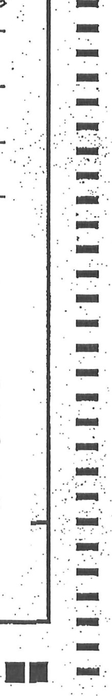

|  |  |  |  |  |  |  |  |  |  |  |  |  |  |  |  |  |  |  |  |  |  |  |  |  |
| --- | --- | --- | --- | --- | --- | --- | --- | --- | --- | --- | --- | --- | --- | --- | --- | --- | --- | --- | --- | --- | --- | --- | --- | --- |
| DIRECTIONS  Jin writing your paper on the lines below. Only what you write on pages 5 through 7 will be scored.   |  |  |  | | --- | --- | --- | | hend a | how people | | |  | hic Ah | | | uptAO | be able | | |  |  | away  Ids |   Dear veac\erg   |  |  |  |  |  | | --- | --- | --- | --- | --- | |  |  |  | be | eh) Aupq and gou won-b |   cheep\g)   |  |  |  |  |  |  |  | | --- | --- | --- | --- | --- | --- | --- | |  | \aere |  | help | vehize |  |  |   belf a e, Co c hel and    heap  can  Page  5 |
| 2830544 |

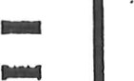—

つワあ

|  |  |  |  |  |  |  |  |  |  |  |  |  |  |  |  |  |  |  |  |  |  |  |  |  |  |  |  |  |  |  |  |  |  |  |  |  |  |  |  |  |  |  |  |  |  |  |  |
| --- | --- | --- | --- | --- | --- | --- | --- | --- | --- | --- | --- | --- | --- | --- | --- | --- | --- | --- | --- | --- | --- | --- | --- | --- | --- | --- | --- | --- | --- | --- | --- | --- | --- | --- | --- | --- | --- | --- | --- | --- | --- | --- | --- | --- | --- | --- | --- |
|  | |  |  |  |  |  |  |  |  |  |  |  |  |  |  |  |  |  |  |  |  |  |  |  |  |  |  |  |  |  |  |  |  |  |  |  |  |  |  |  |  |  |  |  |  |  | | --- | --- | --- | --- | --- | --- | --- | --- | --- | --- | --- | --- | --- | --- | --- | --- | --- | --- | --- | --- | --- | --- | --- | --- | --- | --- | --- | --- | --- | --- | --- | --- | --- | --- | --- | --- | --- | --- | --- | --- | --- | --- | --- | --- | --- | | 0  \  5  硺  (ん e. CO Ⅳ) )し、を・、0 o可00 9 () Ⅱ卩,   |  |  |  |  | | --- | --- | --- | --- | |  |  |  | しuー「丁0 | | 、end 0 |  |  |  |       スけしい、"ハ詩。.gぃ 2  人   |  |  |  |  |  |  | | --- | --- | --- | --- | --- | --- | |  | | 、\()Öki  (。つ Ⅵキ0己ん~ | | | | |  | |  | | | | |  | | e,キⅡ皀。/3 0 000にい「Ⅵ、、,に | | | | | 自し丿 | | 50 ~スー以0、"、い ハノ. (C) (・Ⅵゴド | | |  | |  |  |  |  | | | | DO,い丿へ | | 0 0ー0は | \O(A | 9 0 0 |  |   9  ロ  師  40  ル  。  Page 6 | | PLEASE DO NOT WRITE THIS AREA  2830544 ロ0 (- ) 0 ■ 0 ■ ■〇C)〇〇■ ■〇() ■強0 c)〇〇2830544 | |
|  |
|  |
|  |
|  |
|  |
|  |
|  |
|  |

|  |  |  |  |  |  |  |  |  |  |  |  |  |  |  |  |  |  |  |  |  |  |  |  |  |  |  |  |  |  |  |  |  |  |  |  |  |  |  |  |  |  |  |  |  |  |  |  |  |  |  |  |  |  |  |  |  |  |  |  |  |  |  |  |  |  |  |  |  |  |  |
| --- | --- | --- | --- | --- | --- | --- | --- | --- | --- | --- | --- | --- | --- | --- | --- | --- | --- | --- | --- | --- | --- | --- | --- | --- | --- | --- | --- | --- | --- | --- | --- | --- | --- | --- | --- | --- | --- | --- | --- | --- | --- | --- | --- | --- | --- | --- | --- | --- | --- | --- | --- | --- | --- | --- | --- | --- | --- | --- | --- | --- | --- | --- | --- | --- | --- | --- | --- | --- | --- | --- |
| |  |  |  |  |  |  |  |  |  |  |  |  |  |  |  |  |  |  |  |  |  |  |  |  |  |  |  |  |  |  |  |  |  |  |  |  |  |  |  |  |  |  |  |  |  |  |  |  |  |  |  |  |  |  |  |  |  |  |  |  |  |  |  |  |  |  |  |  |  | | --- | --- | --- | --- | --- | --- | --- | --- | --- | --- | --- | --- | --- | --- | --- | --- | --- | --- | --- | --- | --- | --- | --- | --- | --- | --- | --- | --- | --- | --- | --- | --- | --- | --- | --- | --- | --- | --- | --- | --- | --- | --- | --- | --- | --- | --- | --- | --- | --- | --- | --- | --- | --- | --- | --- | --- | --- | --- | --- | --- | --- | --- | --- | --- | --- | --- | --- | --- | --- | | |  |  |  |  |  |  |  | | --- | --- | --- | --- | --- | --- | --- | |  |  |  |  |  | SO | b(ca-ho | |  | |  | | | |  |      |  |  |  |  |  |  |  |  |  |  | | --- | --- | --- | --- | --- | --- | --- | --- | --- | --- | |  |  |  | | |  |  |  |  | | | O IA | | | eworldÆ& e | | | | co | | | |  | | |  | even •veg o | | |  | | 0 1 |   •s   |  |  |  |  |  |  |  |  |  |  |  |  | | --- | --- | --- | --- | --- | --- | --- | --- | --- | --- | --- | --- | |  |  | |  |  | am ecrhul p li e | | cc |  |  |  |  | |  | |  | | | | e +00, |  | STOP | | | |   Page 7  2830544 | | |  |
|  |
|  |
|  |
|  |

G DOI

#### Score Point: 6

This is a well-developed response in which the writer presents several examples of how "a computer is a very helpful tool" (communicate with far away friends; ability to type school work; the computer is educational). Each reason is fully elaborated with specific details (less expensive than calling your aunt in Russia; you can backspace and print more than one copy; latest fashion trends and political news). Strong organization is demonstrated through the use of sophisticated transitional language, and the response is developed enough for a "6."